User Guide for C# Application
This guide explains how to set up, configure, and run the Sysmetrics application using C#. Please follow the steps carefully to ensure proper operation.

Prerequisites
- A Windows-based computer
- .NET SDK installed
- Visual Studio
- Network access to the target machine

Installation
1. Download the folder named “SysmetricsSourcers” to your computer from Sysmetric-tfs.com\
2. Extract (unzip) the folder contents.
3. Open the solution file named “Sysmetrics.sln”.
4. Build the solution to ensure all dependencies are resolved.

Configuration
Before running the application, you must configure the following files.

Program.cs
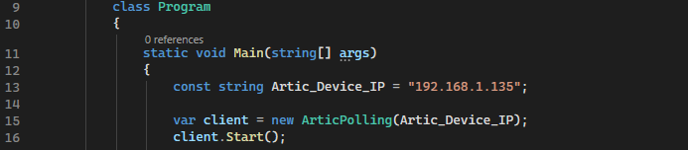
Open the file Program.cs and update the following parameter:
- Machine IP Address: Enter the IP address of the target machine you want to connect to.

ArticPolling.cs
Open the file ArticPolling.cs and configure the following settings:
- Device Type: Specify the device type (Artic or Samson).
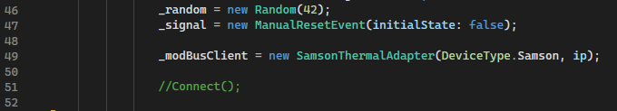

- Desired Temperature: Set the required operating temperature.
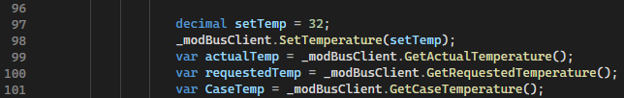

- To turn the machine on or off, locate the relevant lines in the code and comment or uncomment them as needed.
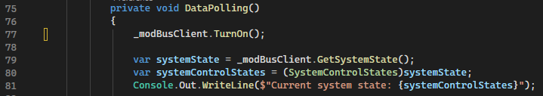

Running the Application
After completing all configuration steps, run the solution from Visual Studio. Monitor the output to confirm that the application is communicating correctly with the device.

Notes
- Ensure the IP address is reachable before running the application.
- Incorrect device type may cause unexpected behavior.
- Be aware that if you “Turn-on” once you do not need to “Turn on” once you change temperature 2nd time (same for “Turn Off”).

